Run Summary

 | Test name: | Profiling
 | Test instance: | Profiling
 | Status: |  | Failed
 | Run name: | Run_10-8_11-28-9
 |  | sa
 | Start time: | 08/10/2014 11:32:12
 | End time: | 08/10/2014 11:57:14
 | Duration: | 00:25:02

Steps | User  Actions | Submitted  Defects | Comments
8 | 45 | 0 | 0

# | Step | User Actions
1 |  Connect to Mercury Tours Site  Open your Web browser and type the <<<Mercury Tours URL>>>.
  1. Simulate the "onmouseover" event on the "Register" image.
  2. Click the "Register" image.
2 | Registration  - Complete the Contact Information section.  - Complete the Mailing Information section.  - Complete the User Information section.  - Click the Submit button.
  3. Enter "Inbar" in the "firstName" edit field.
  4. Enter "Shani" in the "lastName" edit field.
  5. Enter "972" in the "phone" edit field.
  6. Enter "i@i.com" in the "email" edit field.
  7. Enter "K Beit Kama" in the "address1" edit field.
  8. Enter "K Beit Kama" in the "city" edit field.
  9. Enter "Israel" in the "state" edit field.
  10. Enter "85325" in the "postalCode" edit field.
  11. Select the "ICELAND" item from the "country" combo box.
  12. Select the "INDIA" item from the "country" combo box.
  13. Select the "INDONESIA" item from the "country" combo box.
  14. Select the "IRAN" item from the "country" combo box.
  15. Select the "IRAQ" item from the "country" combo box.
  16. Select the "IRELAND" item from the "country" combo box.
  17. Select the "ISRAEL" item from the "country" combo box.
  18. Enter "inbar_shani" in the "userName" edit field.
  19. Enter the encrypted password in the "password" edit field.
  20. Enter the encrypted password in the "confirmPassword" edit field.
  21. Click the "register" image.
3 | Sign-On to Mercury Tours Application  1. Type the <<<User Name>>> in the User Name field.  2. Type the <<<Password>>> in the Password field.  3. Click the Sign-On button.
  22. Simulate the "onmouseover" event on the "sign-on" image.
  23. Click the "sign-on" image.
  24. Enter "inbar_shani" in the "userName" edit field.
  25. Enter the encrypted password in the "password" edit field.
  26. Click the "Login" image.
  27. Close the "Application Blocked" window.
4 |  Click the Profile button.  Click the Profile button.
  28. Simulate the "onmouseover" event on the "profile" image.
  29. Click the "profile" image.
5 | Change Contact Information  - Change the Contact Information section:  - First Name  - Last Name  - Phone  - Email  Click the Submit button.
  30. Enter "New" in the "firstName" edit field.
  31. Enter "New" in the "lastName" edit field.
  32. Enter "0" in the "phone" edit field.
  33. Enter "a@a.com" in the "email" edit field.
  34. Click the "register" image.
6 | Click the Profile button.  Click the Profile button.
  35. Simulate the "onmouseover" event on the "profile" image.
  36. Click the "profile" image.
7 | Change Mailing Information  - Change the Mailing Information section:  - Address  - City  - State / Province  - Postal Code  - Country  Click the Submit button.
  37. Enter "Yehud" in the "address1" edit field.
  38. Enter "Yehud" in the "address2" edit field.
  39. Enter "Yehud" in the "city" edit field.
  40. Enter "Israel" in the "state" edit field.
  41. Enter "56100" in the "postalCode" edit field.
  42. Enter "" in the "address2" edit field.
  43. Click the "register" image.
  44. Simulate the "onmouseover" event on the "profile" image.
  45. Click the "profile" image.

Connect to Mercury Tours Site - Action 1:
Simulate the "onmouseover" event on the "Register" image.
- Submitted Defects:
None

- Comment:
None
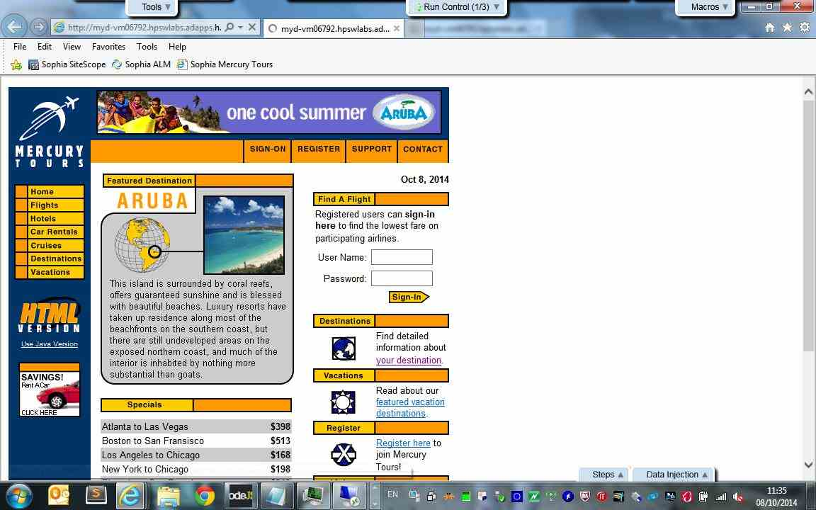

Connect to Mercury Tours Site - Action 2:
Click the "Register" image.
- Submitted Defects:
None

- Comment:
None
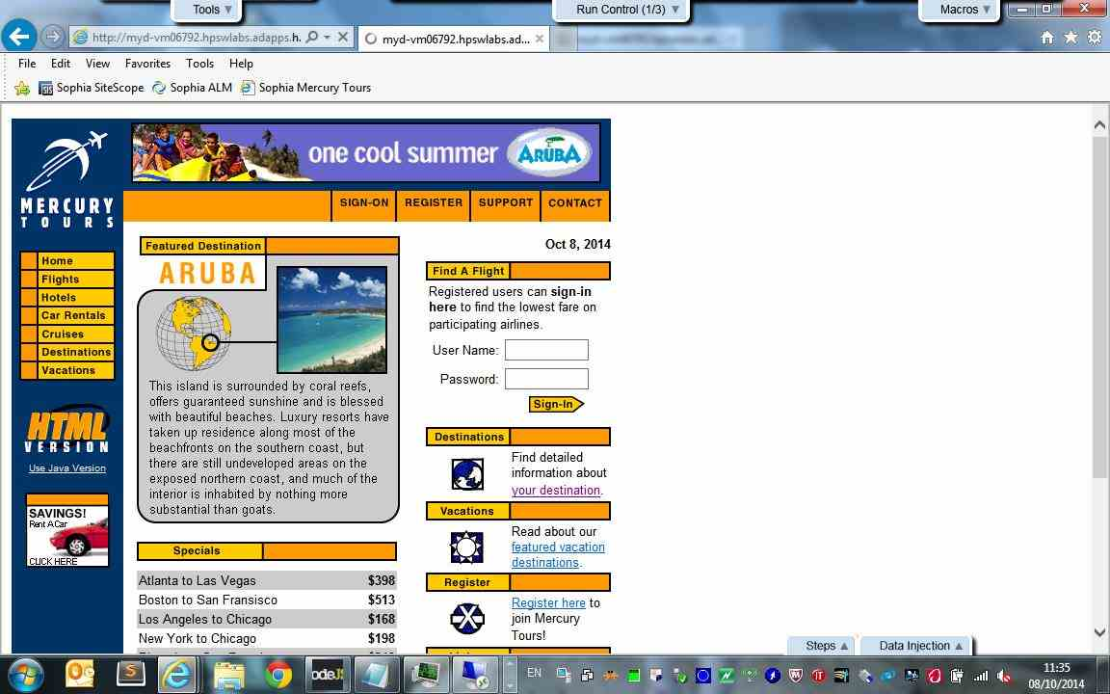

Registration - Action 3:
Enter "Inbar" in the "firstName" edit field.
- Submitted Defects:
None

- Comment:
None
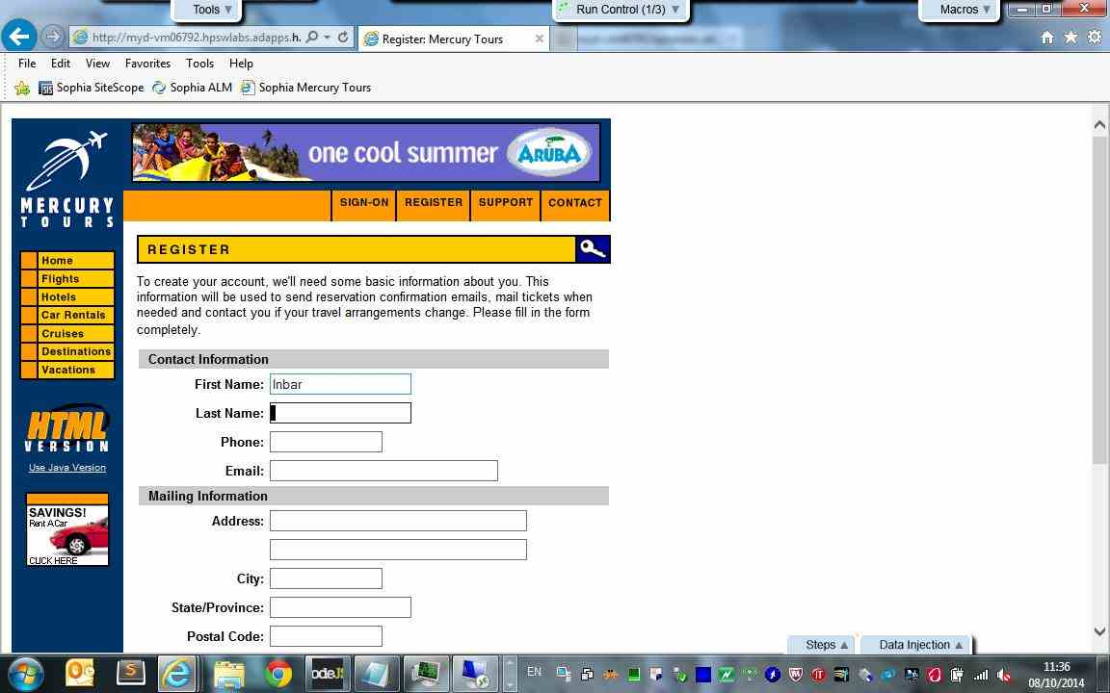

Registration - Action 4:
Enter "Shani" in the "lastName" edit field.
- Submitted Defects:
None

- Comment:
None
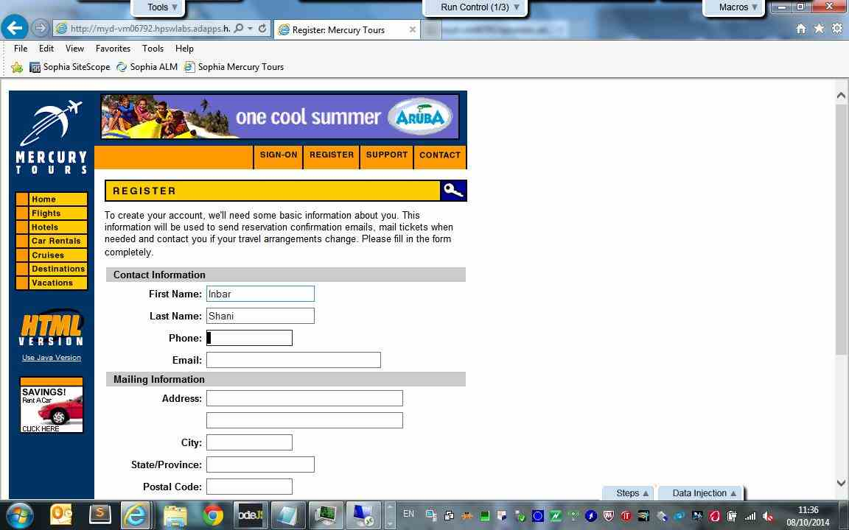

Registration - Action 5:
Enter "972" in the "phone" edit field.
- Submitted Defects:
None

- Comment:
None
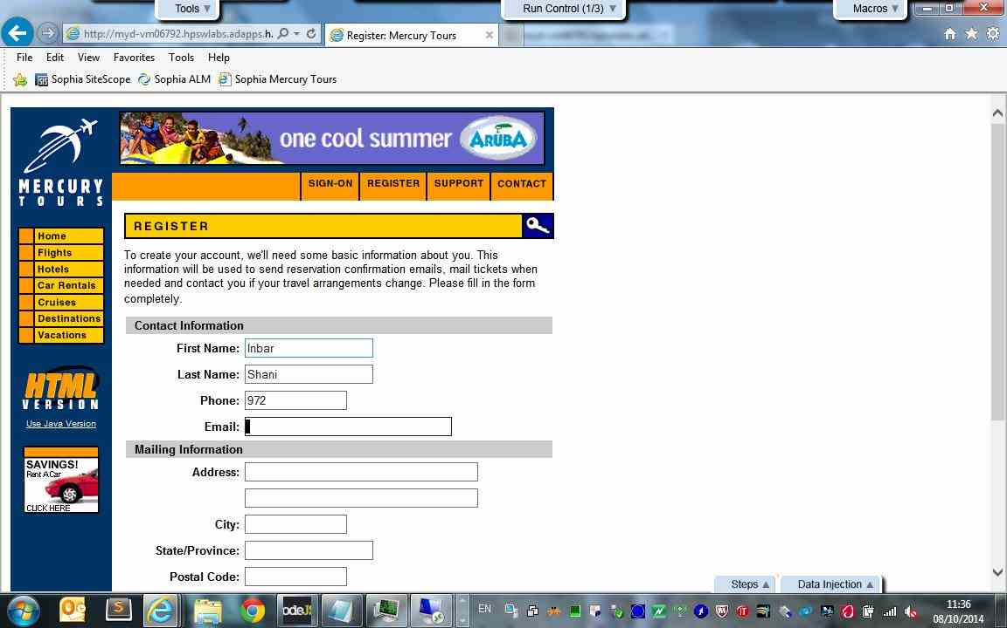

Registration - Action 6:
Enter "i@i.com" in the "email" edit field.
- Submitted Defects:
None

- Comment:
None
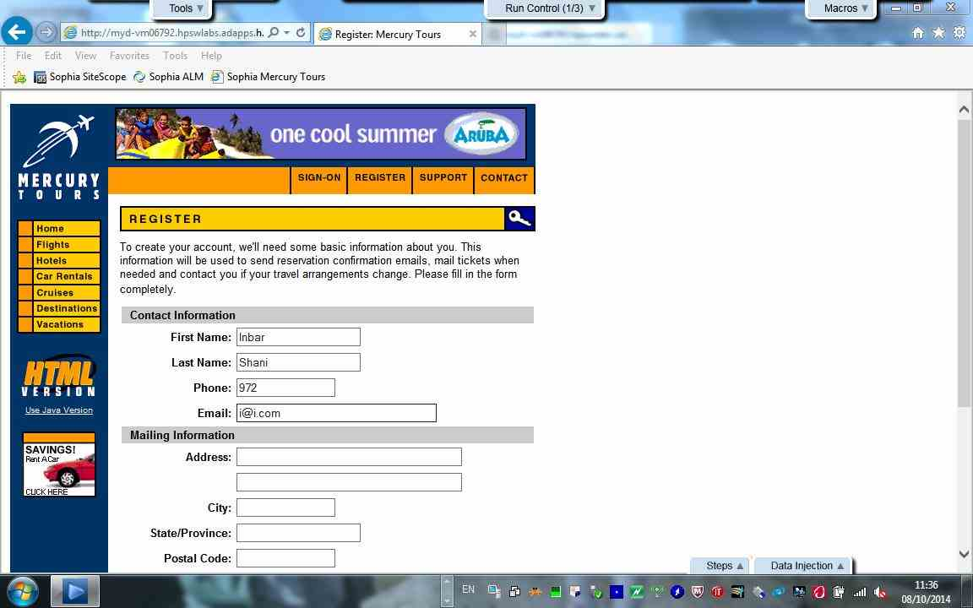

Registration - Action 7:
Enter "K Beit Kama" in the "address1" edit field.
- Submitted Defects:
None

- Comment:
None
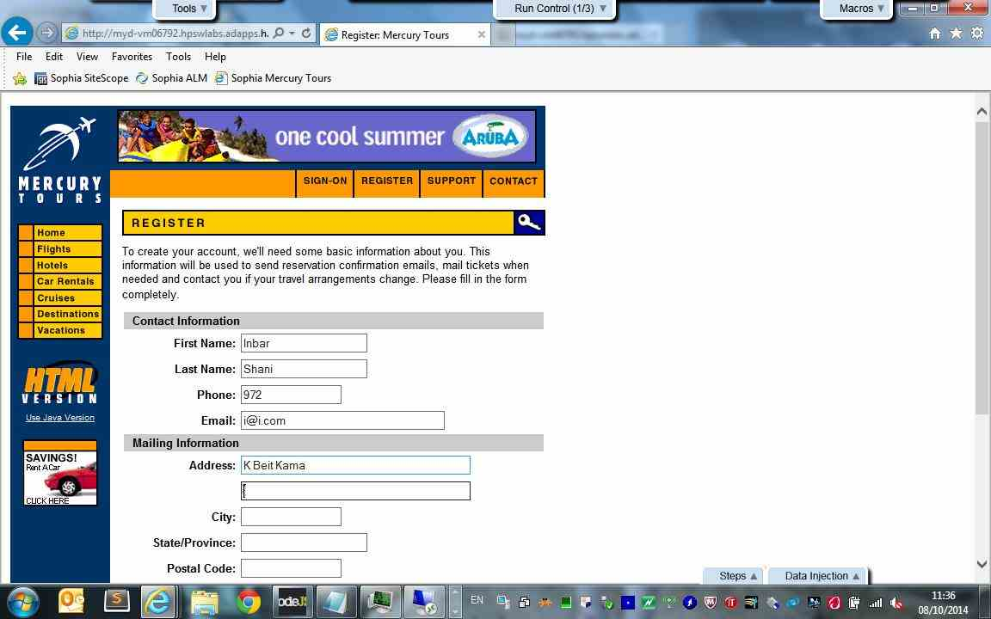

Registration - Action 8:
Enter "K Beit Kama" in the "city" edit field.
- Submitted Defects:
None

- Comment:
None
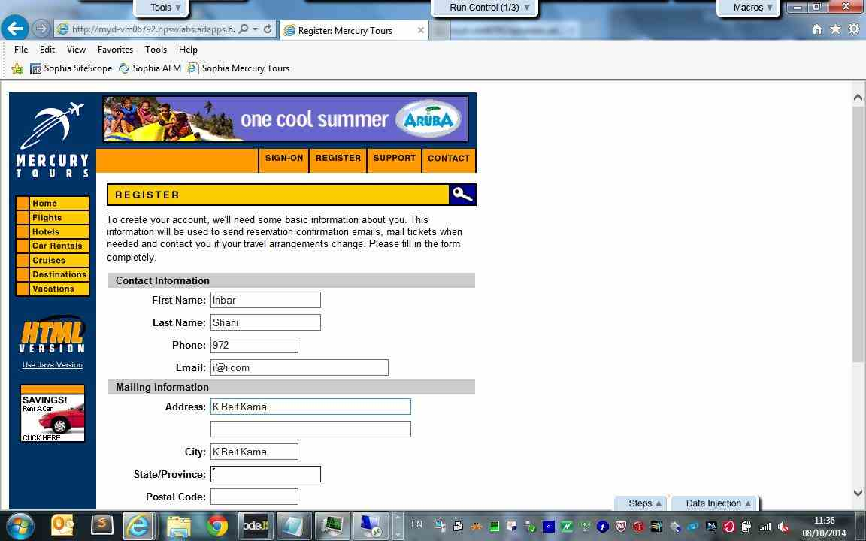

Registration - Action 9:
Enter "Israel" in the "state" edit field.
- Submitted Defects:
None

- Comment:
None
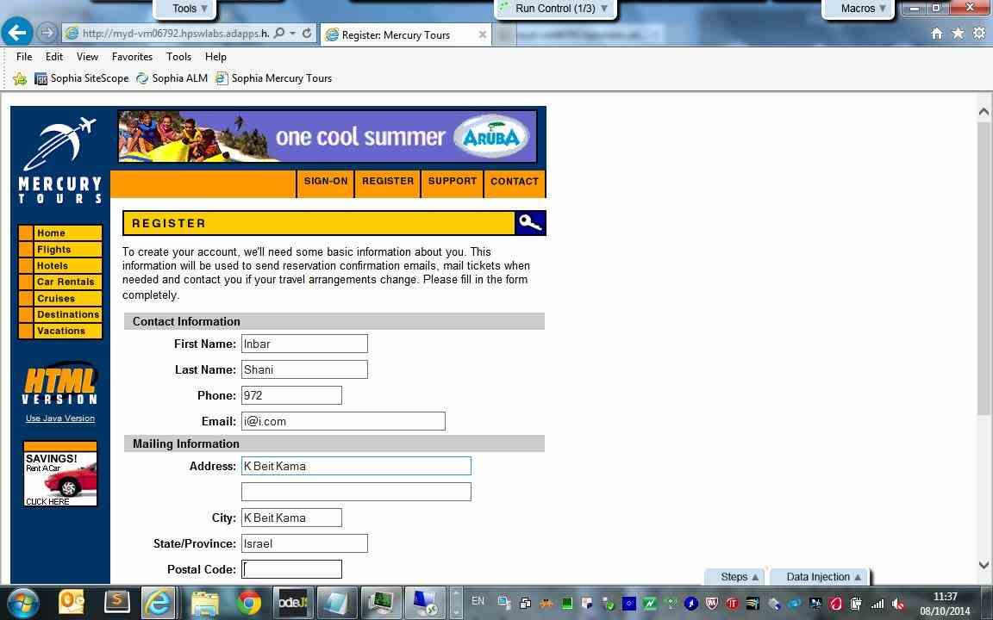

Registration - Action 10:
Enter "85325" in the "postalCode" edit field.
- Submitted Defects:
None

- Comment:
None
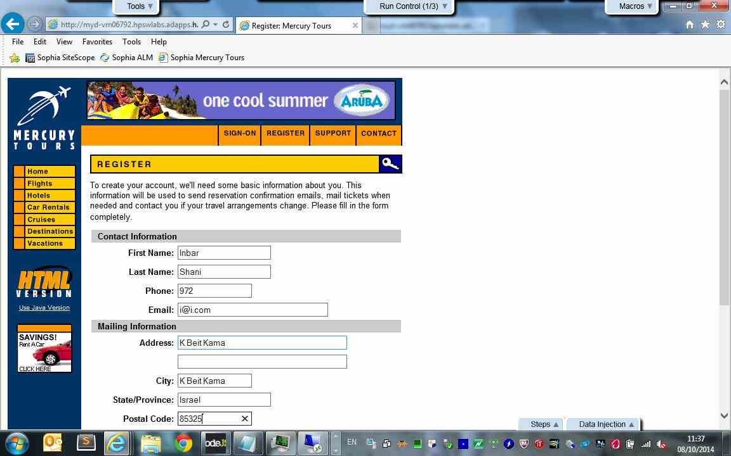

Registration - Action 11:
Select the "ICELAND" item from the "country" combo box.
- Submitted Defects:
None

- Comment:
None
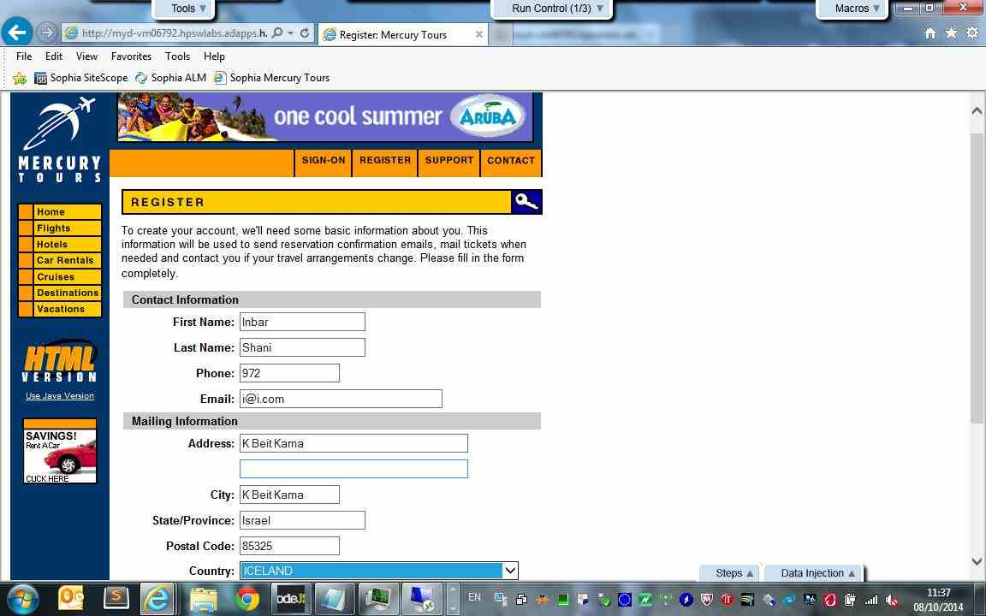

Registration - Action 12:
Select the "INDIA" item from the "country" combo box.
- Submitted Defects:
None

- Comment:
None
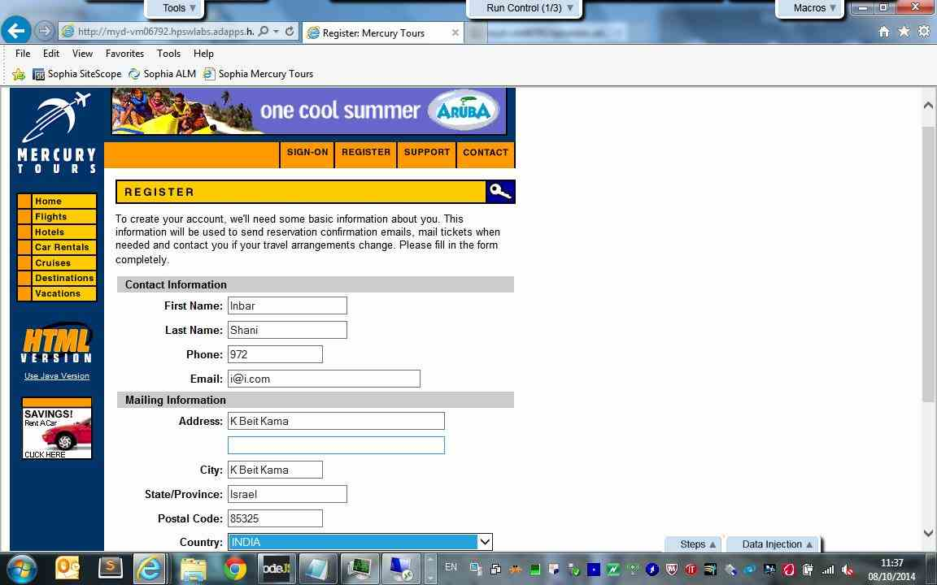

Registration - Action 13:
Select the "INDONESIA" item from the "country" combo box.
- Submitted Defects:
None

- Comment:
None
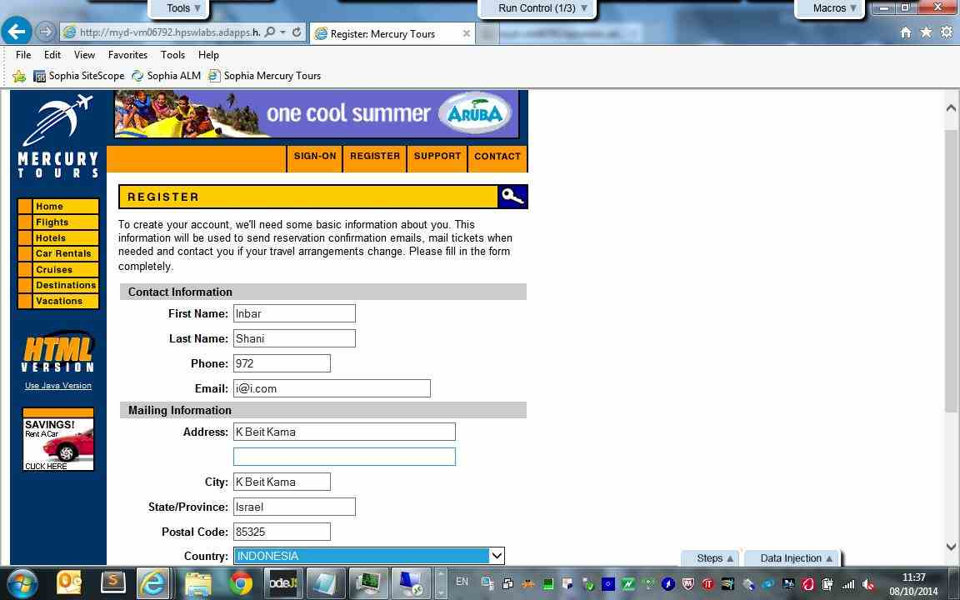

Registration - Action 14:
Select the "IRAN" item from the "country" combo box.
- Submitted Defects:
None

- Comment:
None
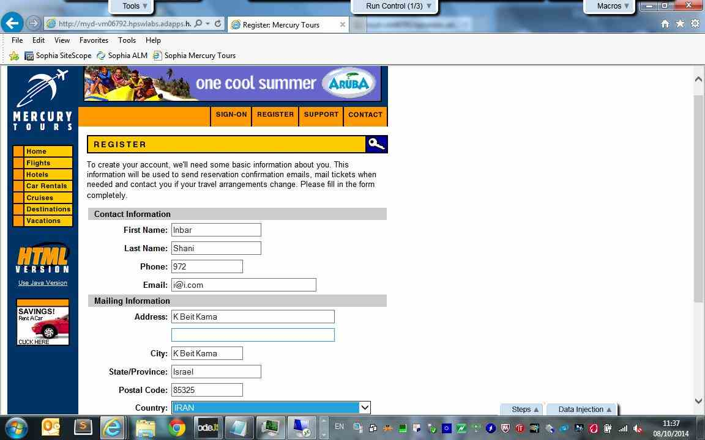

Registration - Action 15:
Select the "IRAQ" item from the "country" combo box.
- Submitted Defects:
None

- Comment:
None
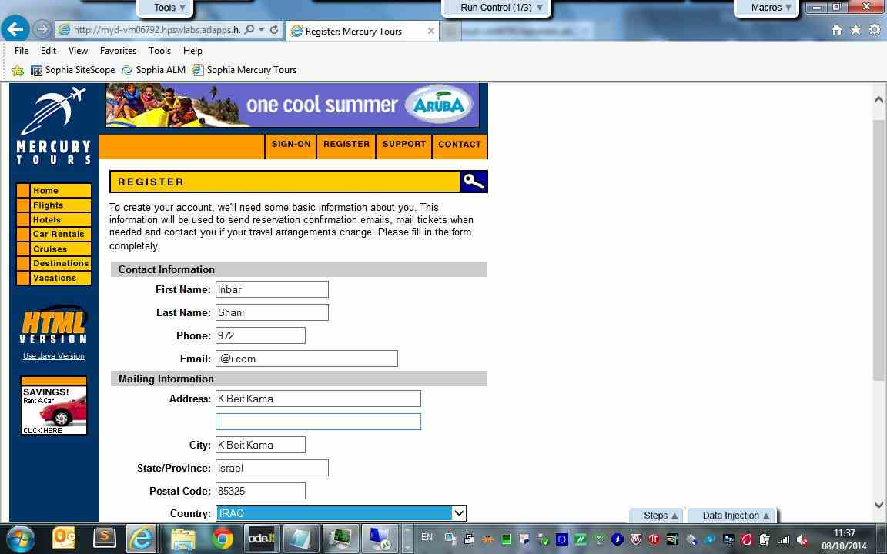

Registration - Action 16:
Select the "IRELAND" item from the "country" combo box.
- Submitted Defects:
None

- Comment:
None
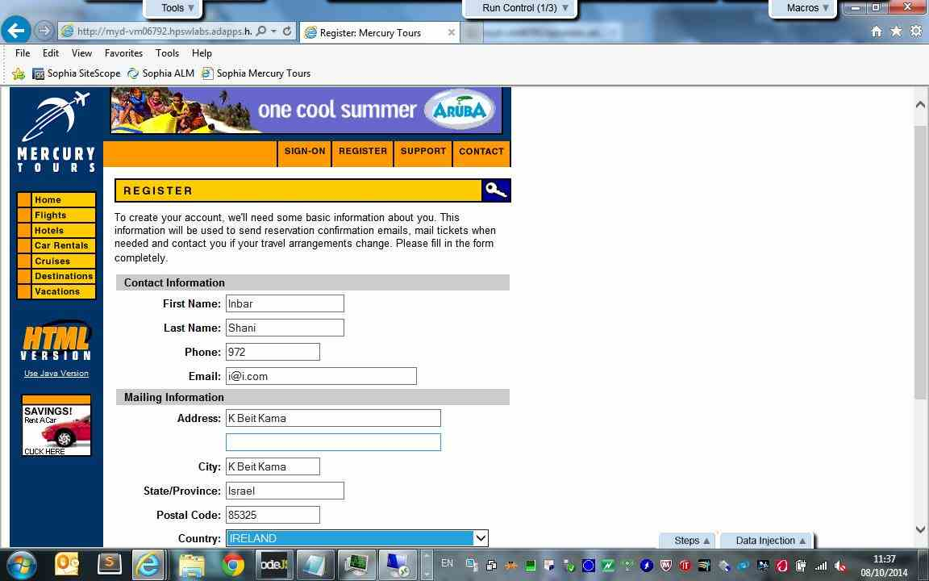

Registration - Action 17:
Select the "ISRAEL" item from the "country" combo box.
- Submitted Defects:
None

- Comment:
None
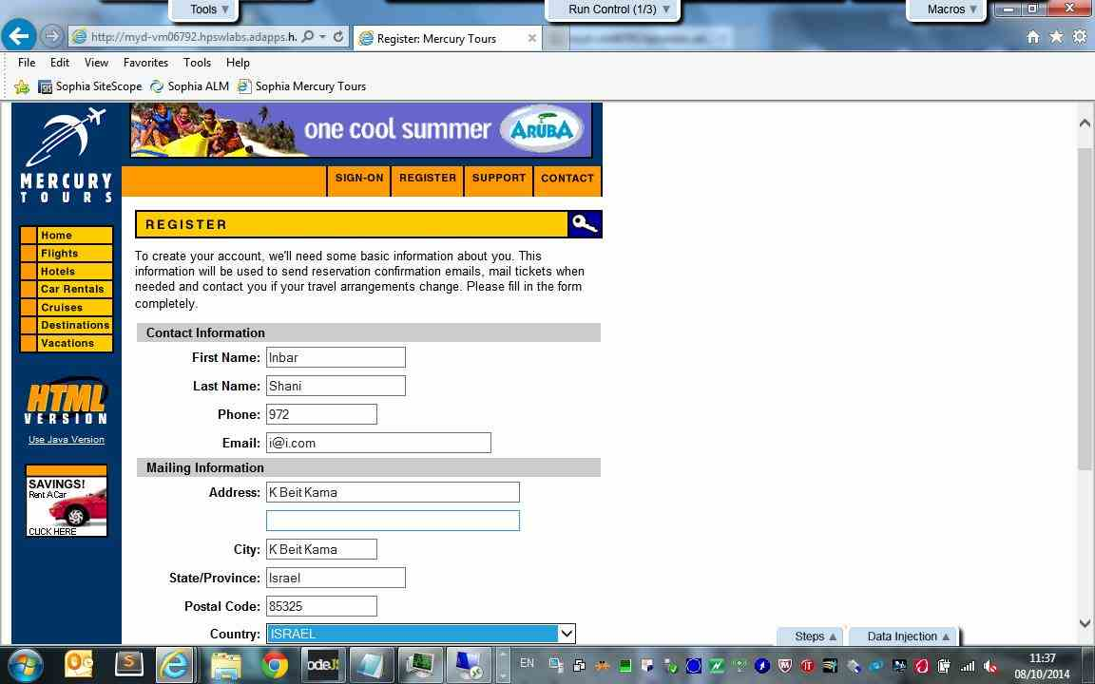

Registration - Action 18:
Enter "inbar_shani" in the "userName" edit field.
- Submitted Defects:
None

- Comment:
None
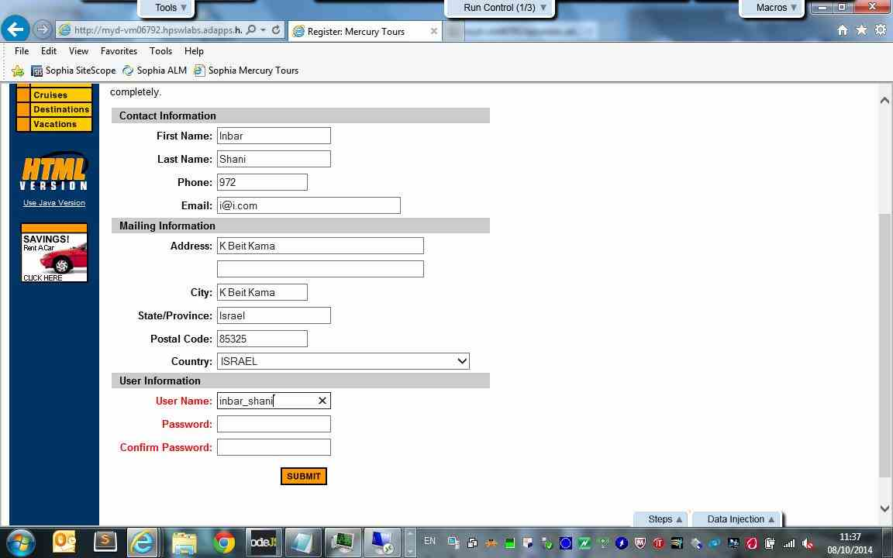

Registration - Action 19:
Enter the encrypted password in the "password" edit field.
- Submitted Defects:
None

- Comment:
None
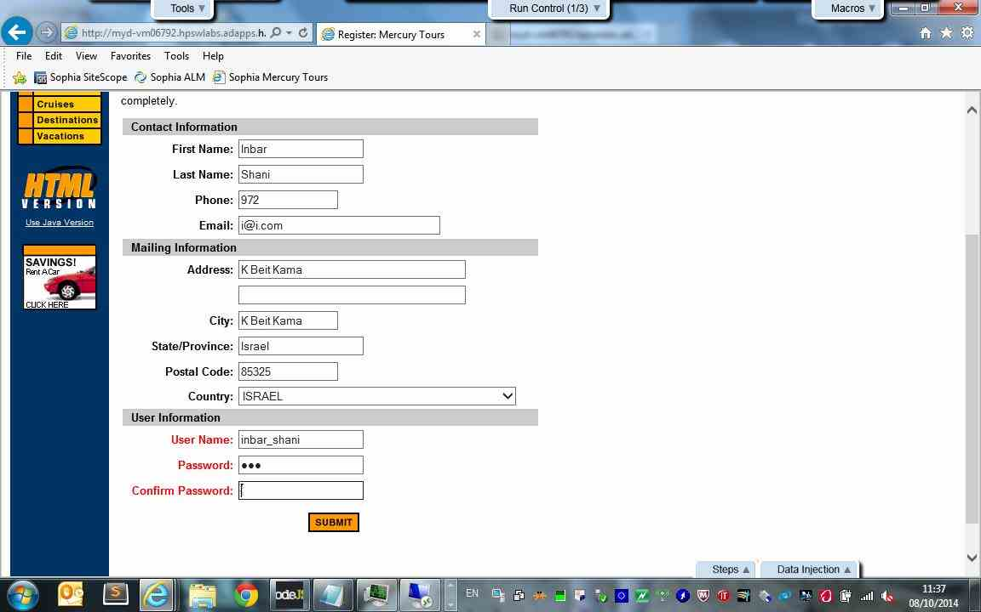

Registration - Action 20:
Enter the encrypted password in the "confirmPassword" edit field.
- Submitted Defects:
None

- Comment:
None
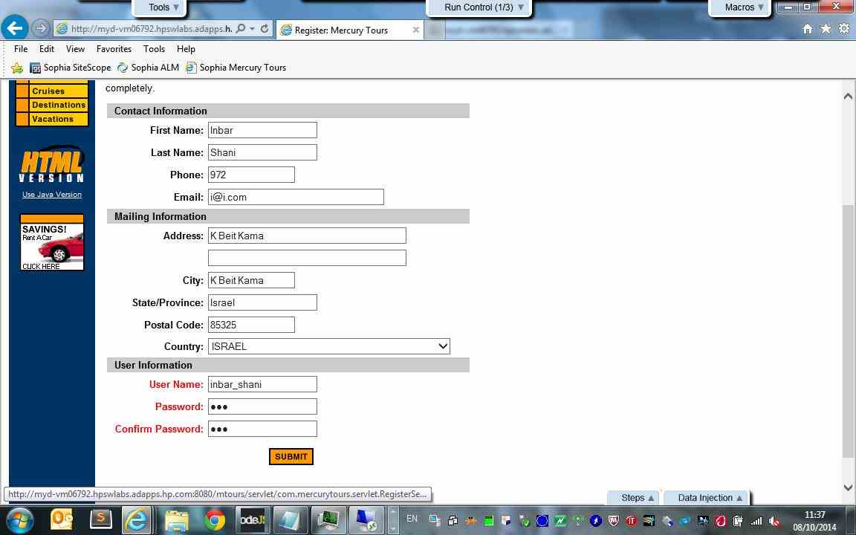

Registration - Action 21:
Click the "register" image.
- Submitted Defects:
None

- Comment:
None
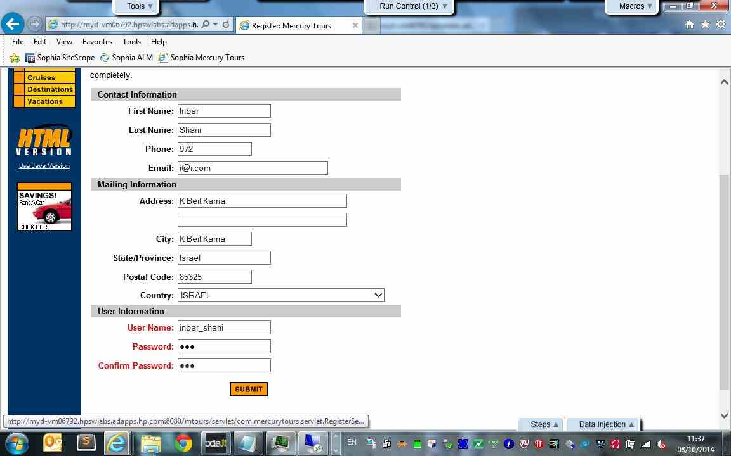

Sign-On to Mercury Tours Application - Action 22:
Simulate the "onmouseover" event on the "sign-on" image.
- Submitted Defects:
None

- Comment:
None
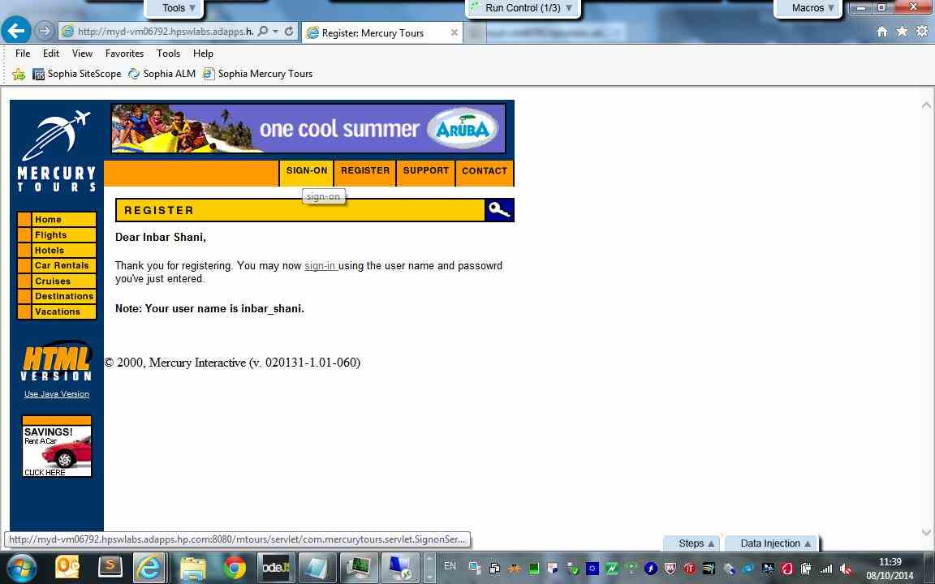

Sign-On to Mercury Tours Application - Action 23:
Click the "sign-on" image.
- Submitted Defects:
None

- Comment:
None
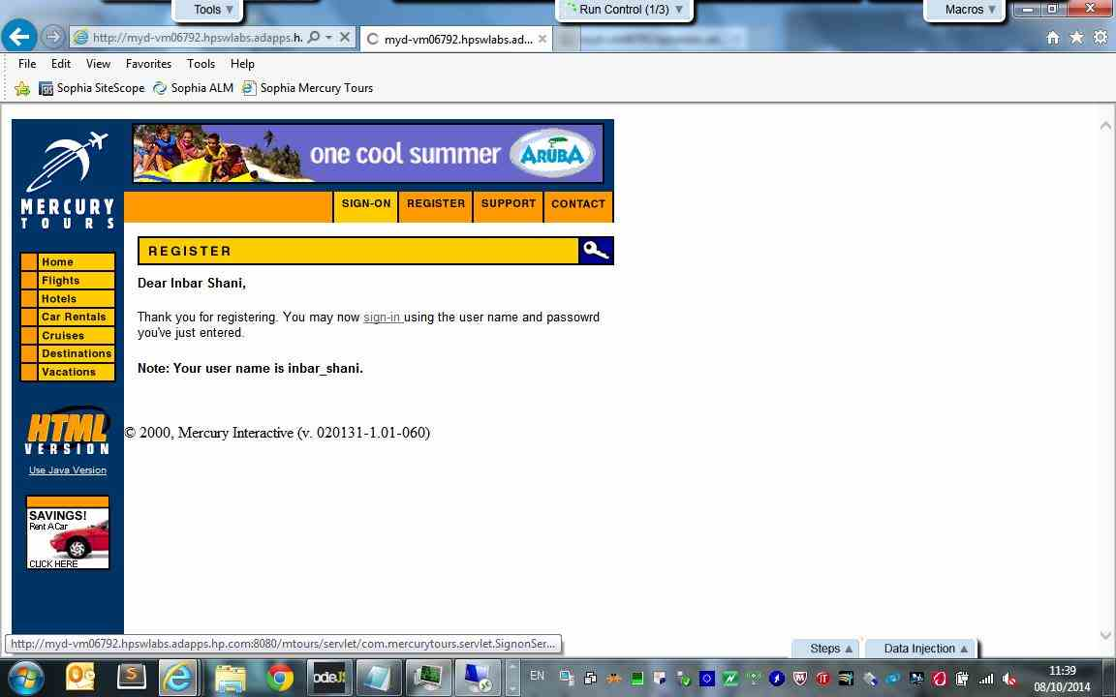

Sign-On to Mercury Tours Application - Action 24:
Enter "inbar_shani" in the "userName" edit field.
- Submitted Defects:
None

- Comment:
None
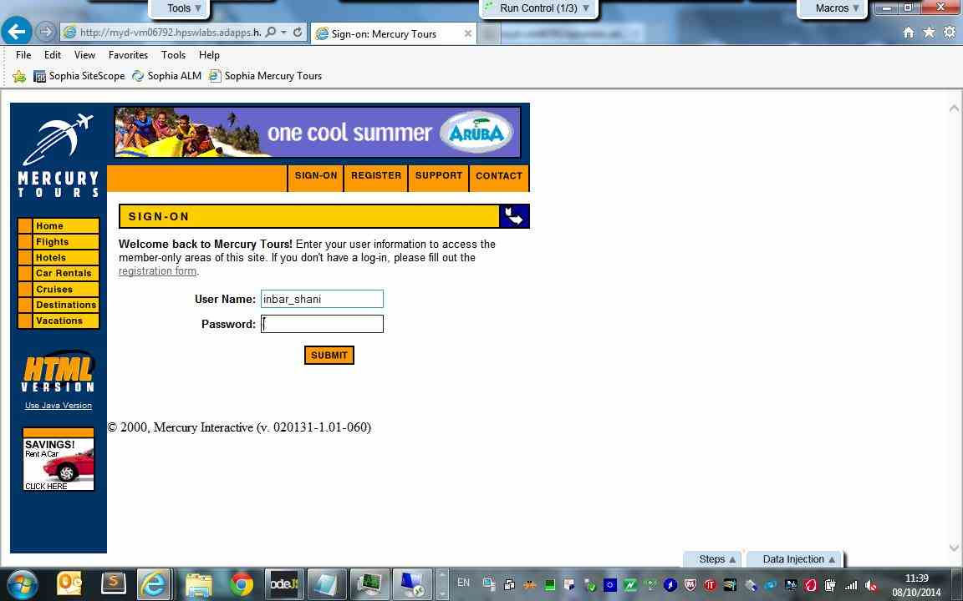

Sign-On to Mercury Tours Application - Action 25:
Enter the encrypted password in the "password" edit field.
- Submitted Defects:
None

- Comment:
None
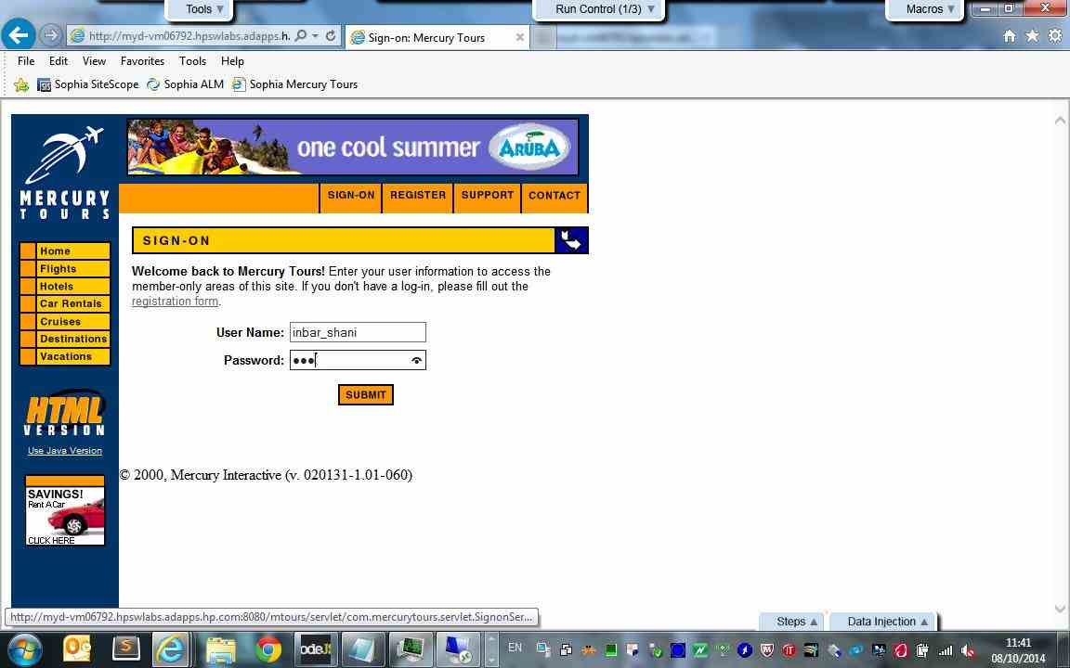

Sign-On to Mercury Tours Application - Action 26:
Click the "Login" image.
- Submitted Defects:
None

- Comment:
None
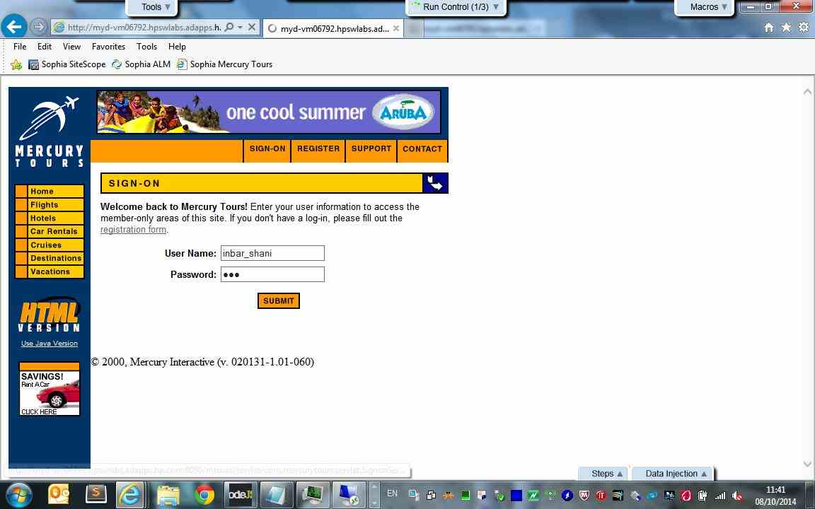

Sign-On to Mercury Tours Application - Action 27:
Close the "Application Blocked" window.
- Submitted Defects:
None

- Comment:
None
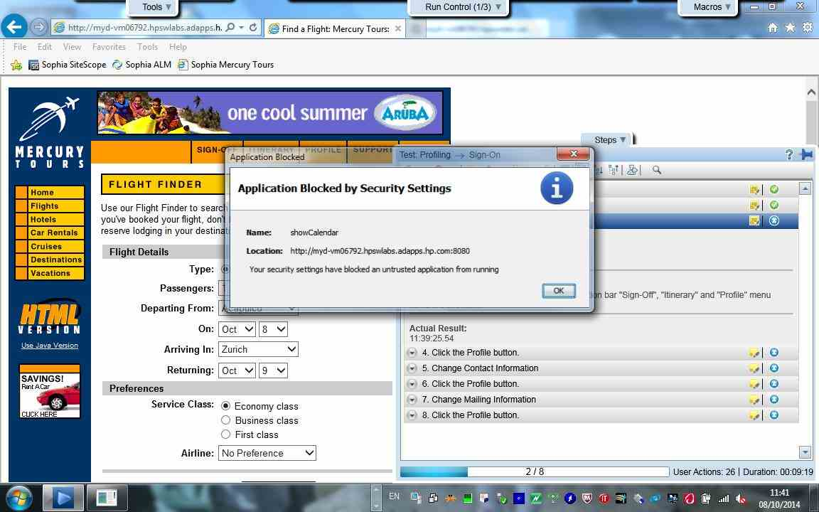

Click the Profile button. - Action 28:
Simulate the "onmouseover" event on the "profile" image.
- Submitted Defects:
None

- Comment:
None
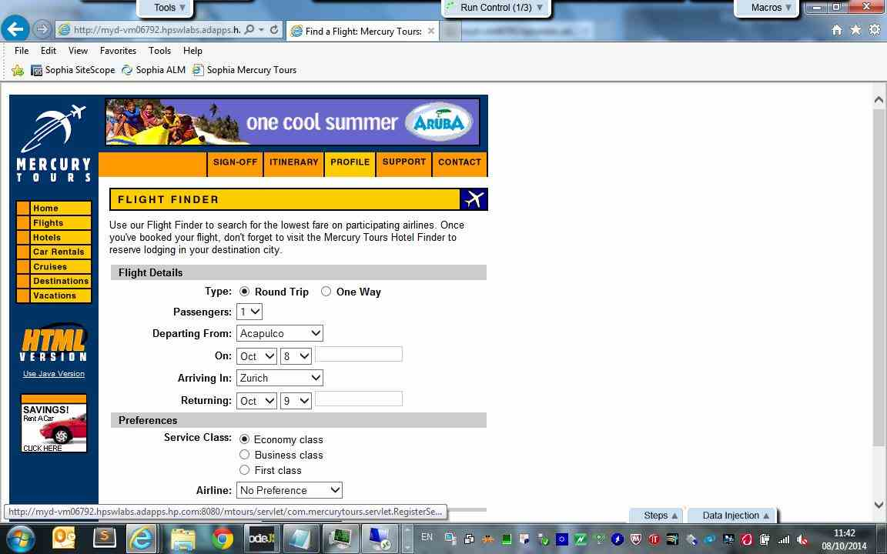

Click the Profile button. - Action 29:
Click the "profile" image.
- Submitted Defects:
None

- Comment:
None
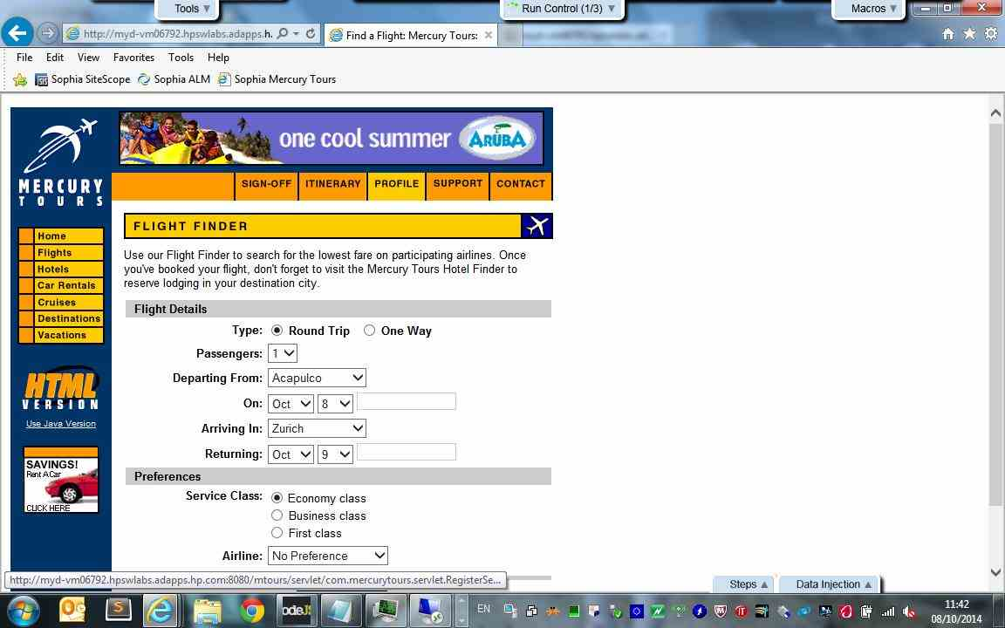

Change Contact Information - Action 30:
Enter "New" in the "firstName" edit field.
- Submitted Defects:
None

- Comment:
None
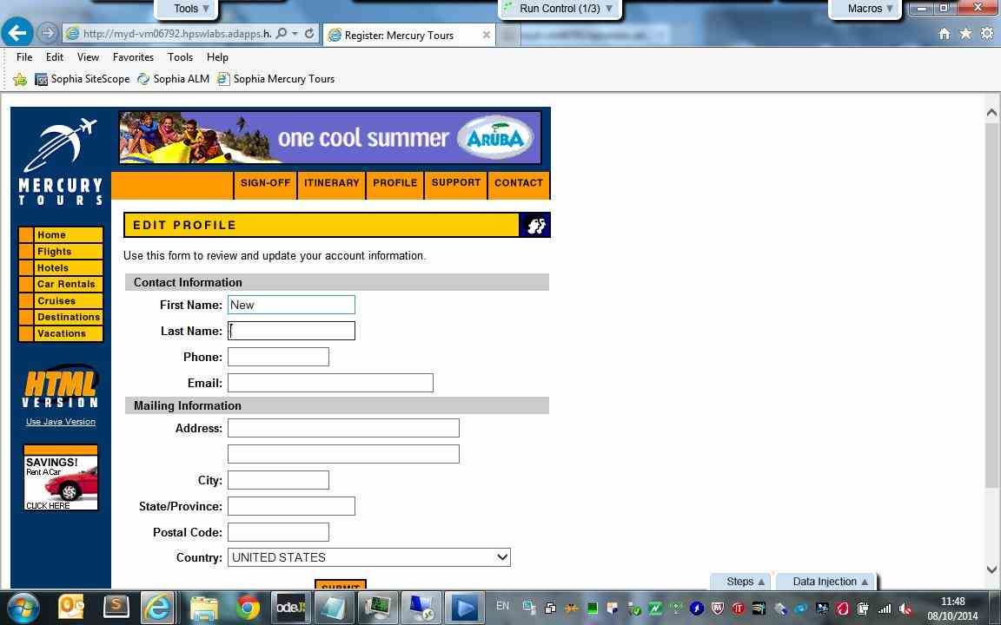

Change Contact Information - Action 31:
Enter "New" in the "lastName" edit field.
- Submitted Defects:
None

- Comment:
None
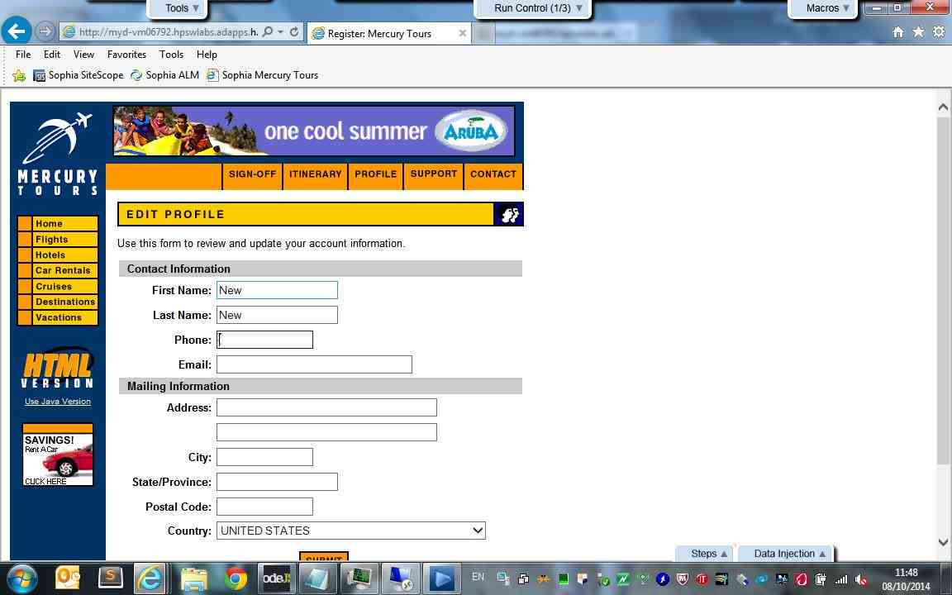

Change Contact Information - Action 32:
Enter "0" in the "phone" edit field.
- Submitted Defects:
None

- Comment:
None
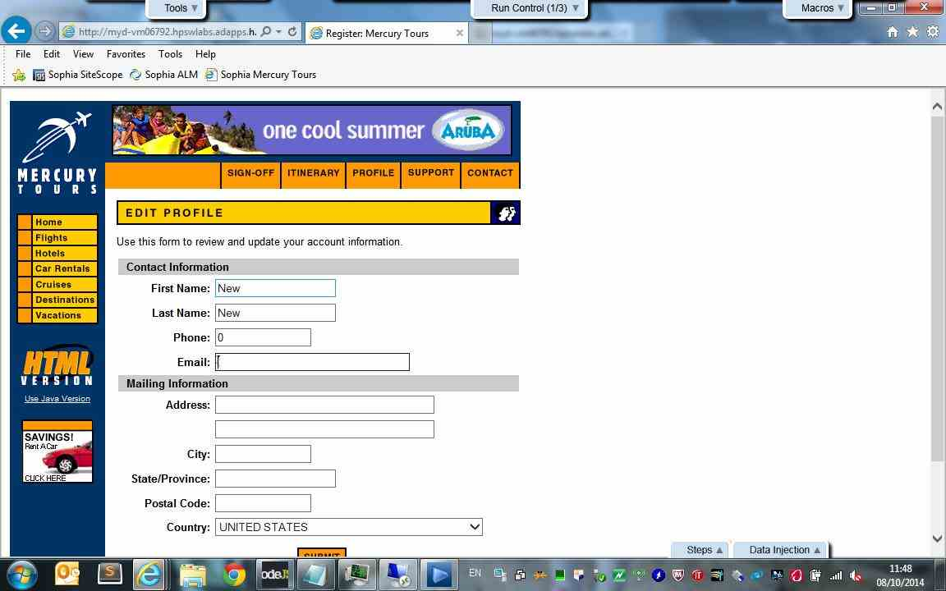

Change Contact Information - Action 33:
Enter "a@a.com" in the "email" edit field.
- Submitted Defects:
None

- Comment:
None
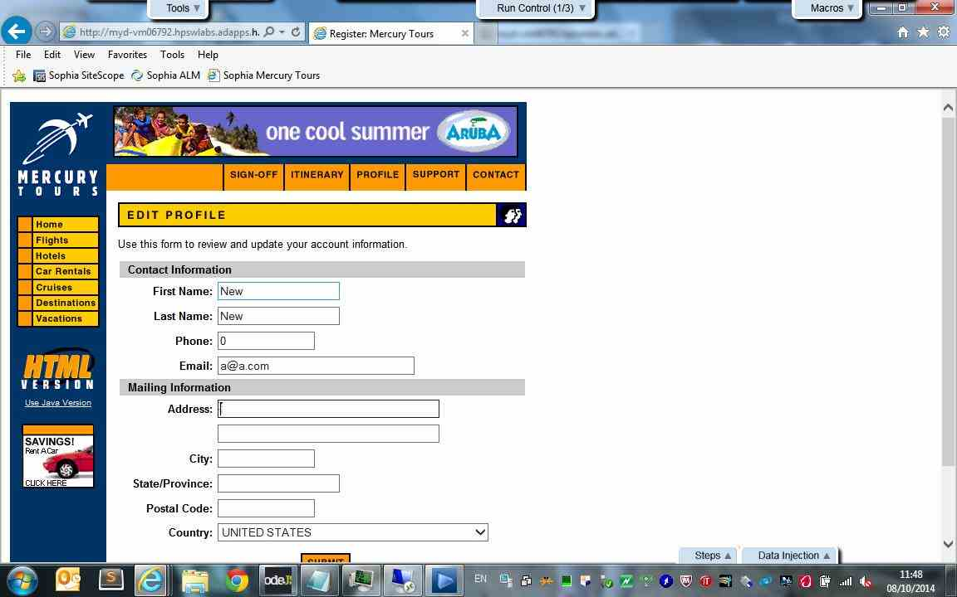

Change Contact Information - Action 34:
Click the "register" image.
- Submitted Defects:
None

- Comment:
None
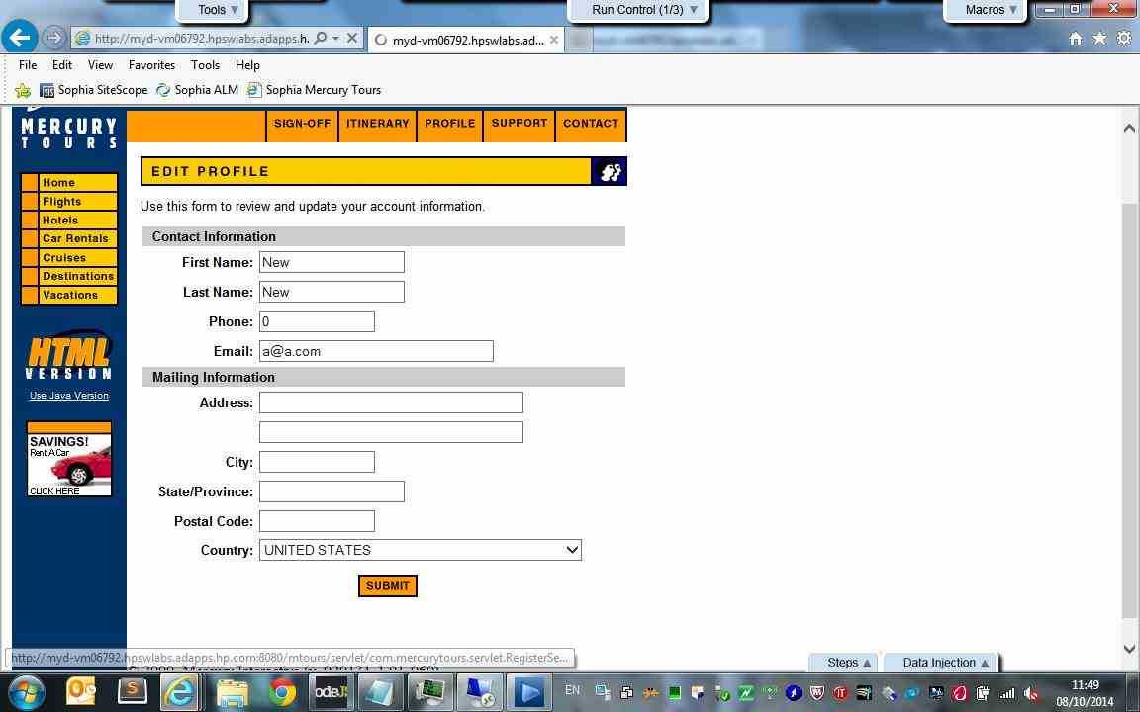

Click the Profile button. - Action 35:
Simulate the "onmouseover" event on the "profile" image.
- Submitted Defects:
None

- Comment:
None
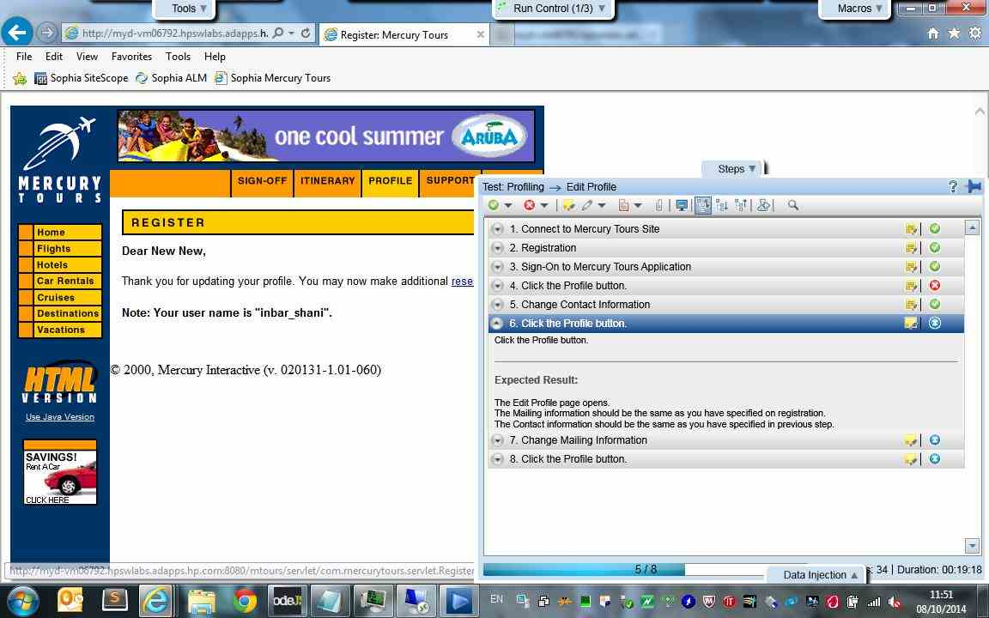

Click the Profile button. - Action 36:
Click the "profile" image.
- Submitted Defects:
None

- Comment:
None
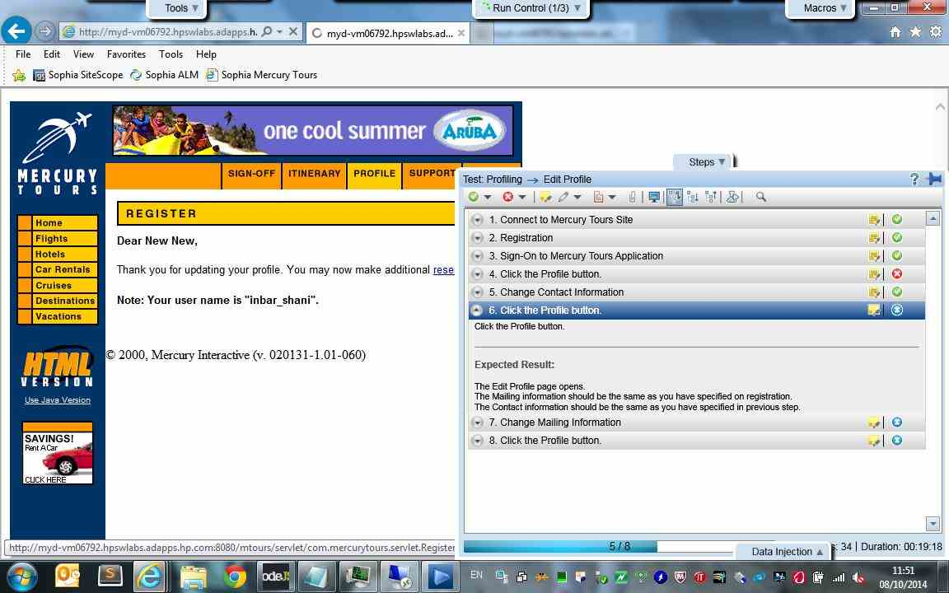

Change Mailing Information - Action 37:
Enter "Yehud" in the "address1" edit field.
- Submitted Defects:
None

- Comment:
None
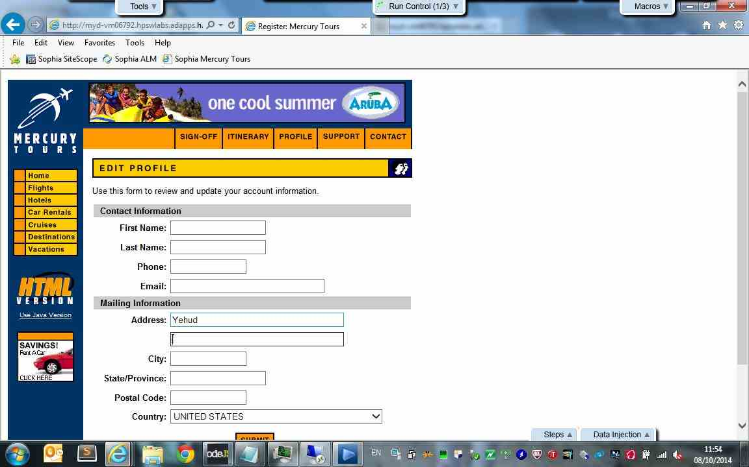

Change Mailing Information - Action 38:
Enter "Yehud" in the "address2" edit field.
- Submitted Defects:
None

- Comment:
None
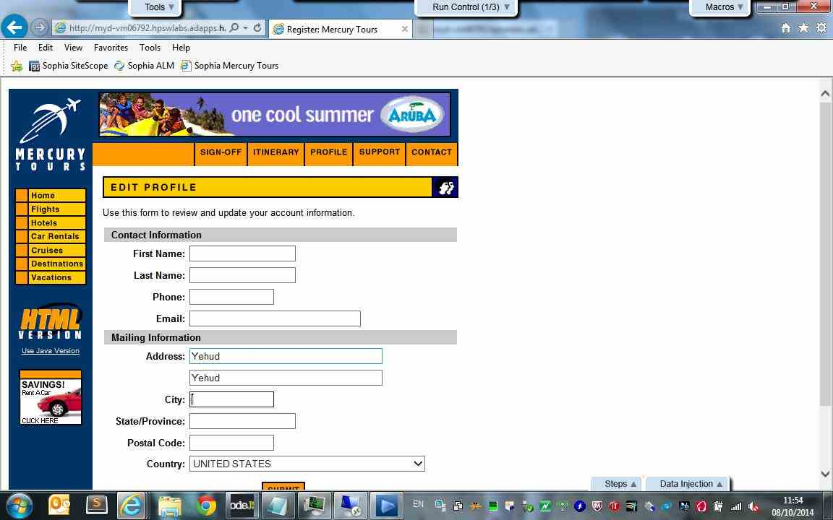

Change Mailing Information - Action 39:
Enter "Yehud" in the "city" edit field.
- Submitted Defects:
None

- Comment:
None
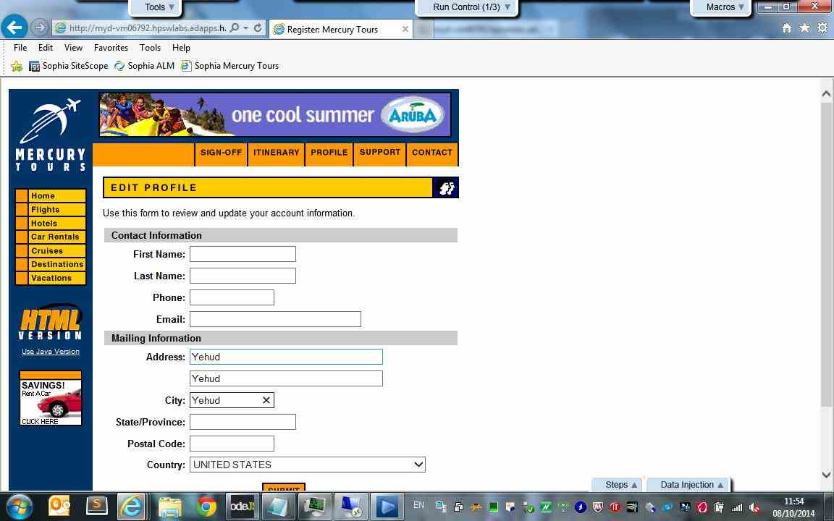

Change Mailing Information - Action 40:
Enter "Israel" in the "state" edit field.
- Submitted Defects:
None

- Comment:
None
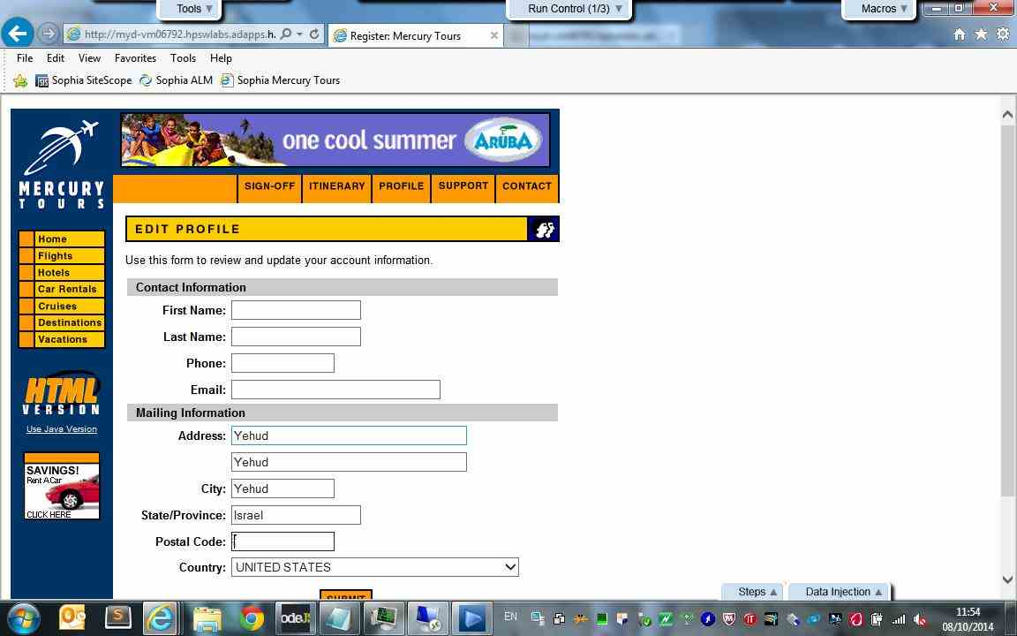

Change Mailing Information - Action 41:
Enter "56100" in the "postalCode" edit field.
- Submitted Defects:
None

- Comment:
None
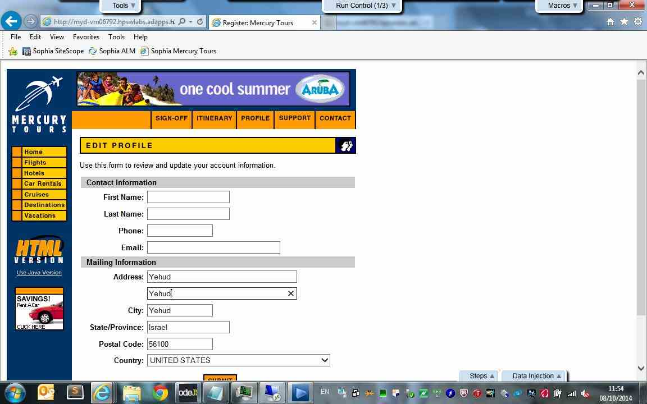

Change Mailing Information - Action 42:
Enter "" in the "address2" edit field.
- Submitted Defects:
None

- Comment:
None
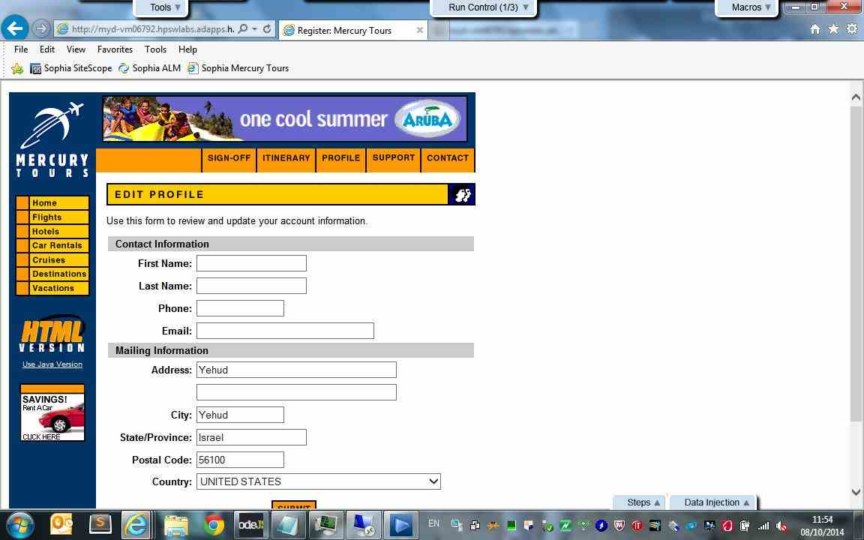

Change Mailing Information - Action 43:
Click the "register" image.
- Submitted Defects:
None

- Comment:
None
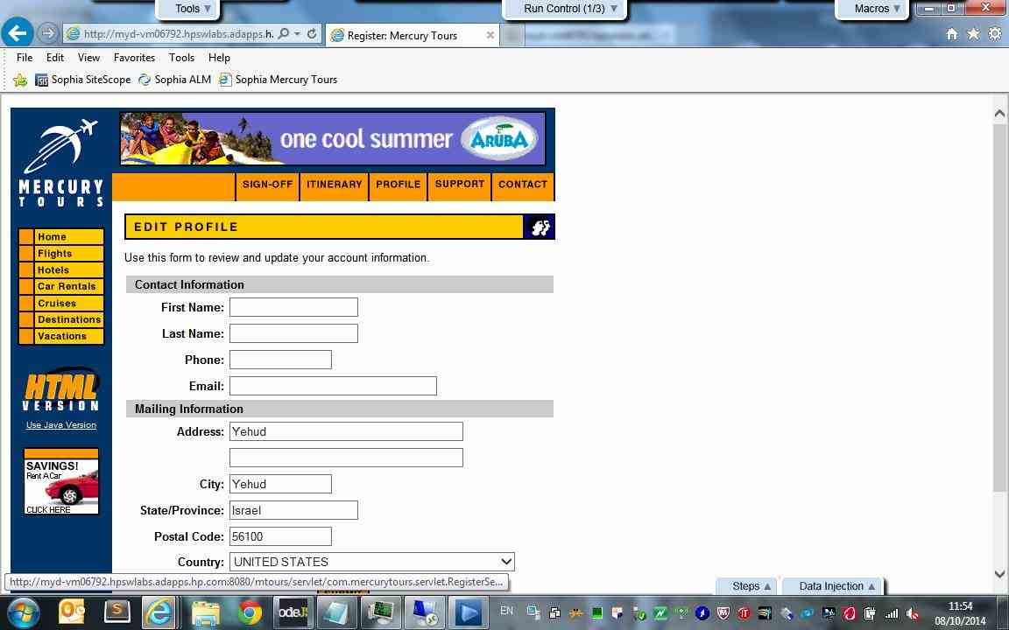

Change Mailing Information - Action 44:
Simulate the "onmouseover" event on the "profile" image.
- Submitted Defects:
None

- Comment:
None
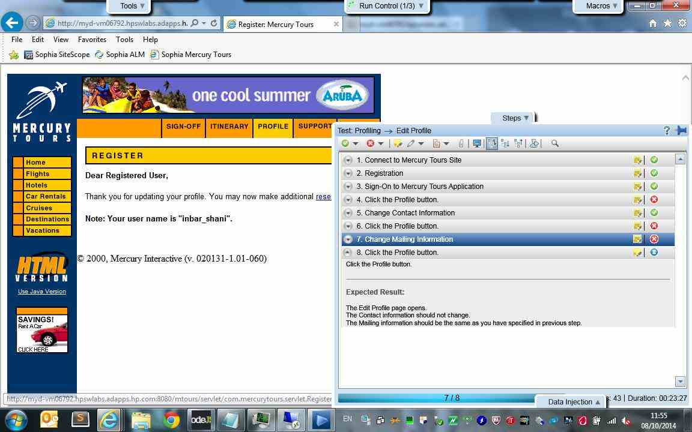

Change Mailing Information - Action 45:
Click the "profile" image.
- Submitted Defects:
None

- Comment:
None
